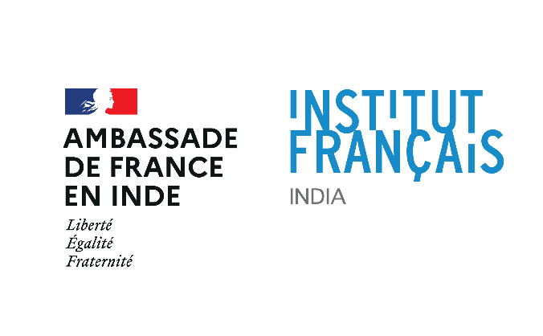

Delhi Government adds French language to the list of global languages being taught in Delhi Government Schools

- Introduction of French language in Delhi government schools will prepare students for a professional life in an increasingly globalized world- Deputy Chief Minister and Education Minister Manish Sisodia
- This educational cooperation between Delhi and French government will pave the way for new collaborations between two countries in the future- Deputy Chief Minister Manish Sisodia
- The Delhi government reflects the same philosophy of education as the French government. This collaboration will bring the life changing experience to students in government schools- Ambassador of France to India, HE Emmanuel Lenain

02 May, New Delhi
Having a knowledge of global languages can lead to great experiences in work, education, and travel, along with exposure to the cultures of the world. To ensure such great global experiences to all the students of Delhi government schools, the Kejriwal government’s Delhi Board of School Education (DBSE) signed the Memorandum of Understanding (MoU) with Institut Français en Inde (IFI - The French Institute in India) on Monday. The MoU to introduce French language in Delhi government schools was signed in the presence of Deputy Chief Minister and Education Minister Manish Sisodia and Ambassador of France to India HE Emmanuel Lenain. On this occasion Mr Sisodia said, “As a part of the Kejriwal Government’s program to introduce prominent global languages in government schools, students will now have the option to learn French too. Introduction of global languages like French will unlock new career options for our students in various fields and will make them professionally sound.”
The Deputy Chief Minister said that learning a global language is not just the acquisition of a skill but also an association with the culture of a particular country. Along with enhancing the potential of students, this educational cooperation will also give an opportunity to students to learn about French culture and history. He added that both countries have been learning from each other since ages in the field of trade, education, art and culture through various collaborations. Hopefully, the students learning French in our schools will become the stronger reasons for more such successful tie ups in future.
Appreciating the progressive efforts of the Kejriwal government for providing an opportunity to government school students to learn global languages, Ambassador of France to India HE Emmanuel Lenain said, “Delhi government reflects the same philosophy of education as the French government. They are serious about their policies and choices for the education of 1.5 million children studying in public schools and we support this cause. Among all the collaborations between two countries, education will always remain our priority. Learning French will be a life changing experience for the students of Delhi government schools and provide them new opportunities academically and professionally.”
Notably, in the pilot phase the French language will be introduced in 30 schools affiliated to DBSE and will be expanded further to other schools depending on children’s interest to learn it. It will be taught in classes VI- XII. Director of Education, Himanshu Gupta informed that IFI will assist DBSE and DOE in training the teachers and resource persons in communicative French language. Under this collaboration IFI will offer access to its cultural and academic platforms to the students in schools. The French Institute will organize workshops and seminars to inform the school students about the possibilities of university studies in France and about the scholarship programme for the benefit of the students.
Benefits of learning French Language
- French is a language of international relations. Learning French can bring in job opportunities in civil or diplomatic services and embassies.
- French can unlock various career opportunities in the field of academics, automobile, aeronautics, travel, tourism, hospitality, fashion etc.
- French is one of the official working languages of many international institutions such as the UN, NATO, UNESCO, WHO, UNHCR, UNCTAD.
- Learning French will give the students exposure to a new culture and art forms.

Others present at the event were:
- Principal Secretary (Education) and Vice President DBSE H Rajesh Prasad;
- Country Director French Institute in India Emmanuel Lebrun-Damiens;
- Director (Education) and Chairperson EC, DBSE Himanshu Gupta;
- Special Secretary (Education) and CEO SOSE C. Arvind;
- CEO DBSE and Regional Director-East, DoE K S Upadhyay;
- Attaché for Cooperation in Education, Embassy of France, Fatiha Kammoussi;
- Attaché for Cooperation in French Language, Embassy of France, Maryline Laidin.

For more information and interview request, contact: Marie-Chanel Gillier, Communications, IFI – mcg@ifindia.in
About the French Institute in India (IFI)
The French Institute in India (Institut Français en Inde - IFI) is the educational, scientific and cultural department of the Embassy of France in India. It facilitates academic and scientific exchanges between higher institutes of learning and research, enables student mobility, and promotes the French language, and artistic and cultural partnerships. Cooperation between India and France takes place through a number of sectors: Arts & Culture, Books, Ideas, French Language & Education, the Study in France programme, Academic Partnerships, Science Technology, as well as Innovation and Multimedia. www.ifindia.in
